Phase 3

10 classes

Day 9 : June 24 2024

Rest full web service

Micro service : small service.

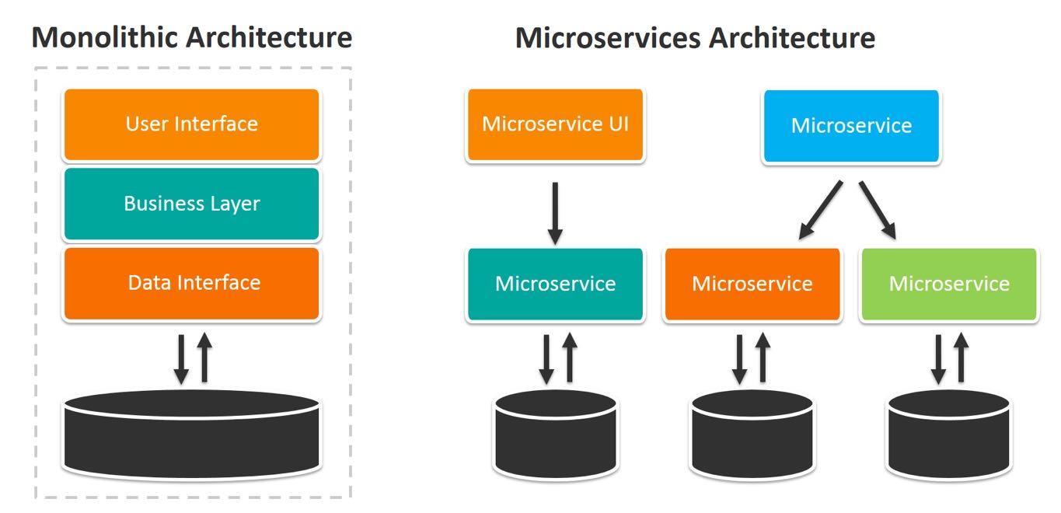

In monolithic or rest full web service, while developing the application all modules like login module, account module, customer module, payment module etc.

1. All modules must be created using same language with same database.
2. All modules if created by different team or person we need wait for all team work to finish and them we need to create one jar file or war file or package and deploy on server.
3. If future if we need any change in any one of the module or if any issue occurs in any module the whole application can’t run.

In micro service architecture rather than deploying all module once we create deploy each module independently develop using same language or other language using same database or other database.

Each module we are deploying using different port numbers. He communication between one micro service to another micro service using rest api call.

To achieve micro service concept in spring boot it provided

Spring cloud : This cloud module provide one of the open source Eureka Server. This server help us to deploy more than one micro service project. It provide health of each micro service project part of Eureka Server.

First Project : Eureka Server

Starter : Web Starter

Starter :Eureka Starter

